Document Name | IP13.14 Modern Slavery Policy Statement
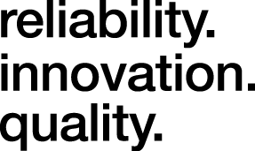
Crossland Tankers Ltd (CTL) manufacture, refurbish and repair road tankers for the chemical, bitumen, waste, milk & food industries. In undertaking these works, CTL confirms understanding of and compliance with all requirements of the Modern Slavery Act 2015, confirming that we do not, or will not in the future, support or do business knowingly with any other party involved in any act of slavery, servitude, forced or compulsory labour, human trafficking or exploitation, all of which have in common the deprivation of a person’s liberty by another in order to exploit them for personal or commercial gain. CTL acknowledge all of these modern slavery acts as immoral and as committing an offence under the Modern Slavery Act 2015.
CTL have a zero-tolerance approach to modern slavery and are committed to acting ethically and with integrity in all our business dealings and relationships and to implementing and enforcing effective systems and controls to ensure modern slavery is not taking place anywhere in our own business or supply chain.
To ensure compliance within our business:
CTL are committed to ensuring there is transparency in our own business and in our approach to tackling modern slavery throughout our supply chain.
CTL have transparent recruitment processes in place which are reviewed regularly. New employees are checked to confirm their identities and ensure their right to work.
CTL have implemented a number of processes to ensure, as reasonably practicable, that our supply chain adhere to the same expectations in respect of their workforce. We require our supply chain to have completed our ethical trading pre-qualification process demonstrating and confirming that modern slavery does not take place within their business or supply chain.
CTL provide training to relevant employees to ensure a high level of understanding of the risks of modern slavery in our business and supply chain and to enable them to identify signs of modern slavery.
CTL aim to encourage openness and will support anyone who raises genuine concerns in good faith under this policy, even if they turn out to be mistaken. We are committed to ensuring no one suffers any detrimental treatment as a result of reporting in good faith their suspicion that modern slavery of whatever form is or may be taking place in any part of our own business or in any part of our supply chain.
CTL expect the same high standards from all of our interested parties and expect that our supply chain will hold their own supply chain to the same high standard as we hold our own business and supply chain to.
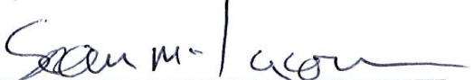

Signed: ____________________________________ Date: 11/05/2022
Sean McKeown Review Date: May 2023
(Managing Director)

